Example Session – Global Energy Transition

Instructor: Nate Tucker

Date: 23-Jan-2021

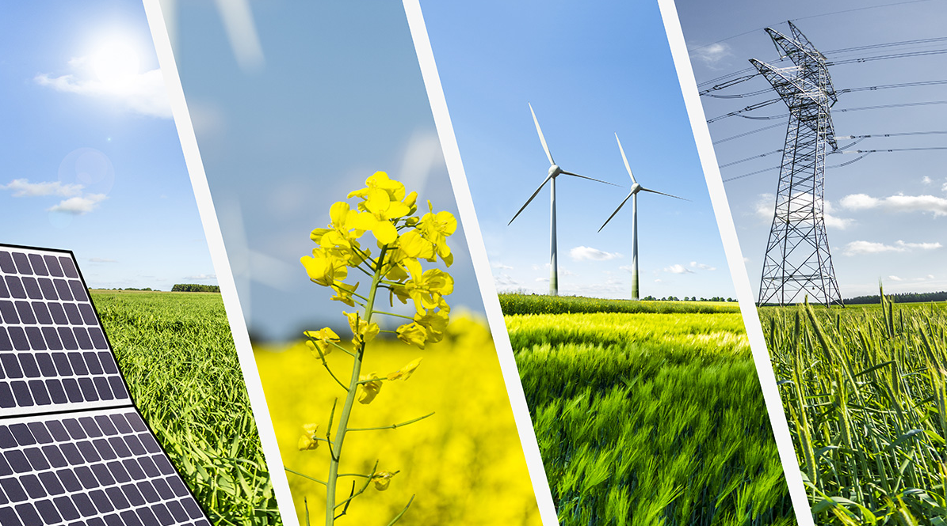

# About Me: (Instructor – Nate Tucker)

* Favorite Food:
* Ideal future job:

[Winter 2019: Nathaniel Tucker | Center for Control, Dynamical Systems and Computation | UC Santa Barbara](https://www.ccdc.ucsb.edu/content/winter-2019-nathaniel-tucker)

[Grad Spotlight: Nathaniel Tucker | Electrical and Computer Engineering | UC Santa Barbara](https://www.ece.ucsb.edu/spotlights/grad-spotlight-nathaniel-tucker)

[Nathaniel Tucker](https://nathanieltucker.github.io/)

# About Us: (Students)

* Ramsay Birkhahn
  + Favorite food:
  + Ideal future job:
* Caroline Keohane
  + Favorite food:
  + Ideal future job:
* Alexa Nares
  + Favorite food:
  + Ideal future job:
* Erika Nares
  + Favorite food:
  + Ideal future job:
* Karla Medrano
  + Favorite food:
  + Ideal future job:
* Carlos Valencia
  + Favorite food:
  + Ideal future job:
* Diego Ramirez
  + Favorite food:
  + Ideal future job:
* Catalina Gallardo
  + Favorite food:
  + Ideal future job:
* Rowen Manriquez
  + Favorite food:
  + Ideal future job:
* Abigail Marin Iniestra
  + Favorite food:
  + Ideal future job:

# Course Overview:

* 5 Saturday Meetings - Discussion oriented
  + Intro to Energy
  + Conventional Energy Sources (coal, oil, etc.)
  + Renewable Energy Sources (wind, solar, tidal, geothermal, hydro, etc.)
  + Upcoming Technologies, Future Goals, Industry Shifts
  + Sustainability in our lives

# Main Goals:

* Introduction to renewable energy sources and upcoming renewable technologies
  + Can renewable energy be as effective as traditional energy sources, just with a few extra hurdles that need to be resolved?
* Introductory knowledge of wind/solar/geothermal/tidal/nuclear generation as well as the conventional generation methods (coal, oil, etc.)
* Be able to look at our own lives and identify sustainable practices and potentially improve our own energy usage.

# What is Energy???

* Energy makes change possible. We use it to do things for us. It moves cars along the road and boats over the water. It bakes a cake in the oven and keeps ice frozen in the freezer. It plays our favorite songs on the radio and lights our homes.
* Scientists define energy as the ability to do work. Modern civilization is possible because we have learned how to change energy from one form to another and use it to do work for us and to live more comfortably.
* Forms of Energy: Energy is found in different forms including light, heat, chemical, and motion. There are many forms of energy, but they can all be put into two categories: potential and kinetic.

# Engagement

1. How do we use energy in our daily lives? In the classroom?
2. How do we generate the electricity used in this classroom or at home?
3. Are those renewable or non-renewable resources? Are there alternatives?
   1. Non-renewables:
   2. Renewables:
4. How do we heat this classroom or our homes?
5. Are those renewable or non-renewable resources? Are there alternatives?
6. What energy source do we use to fuel our vehicles?
7. Is this a renewable or non-renewable resource? Are there alternatives?
8. What other types of resources do we use in California and throughout the world to generate energy?

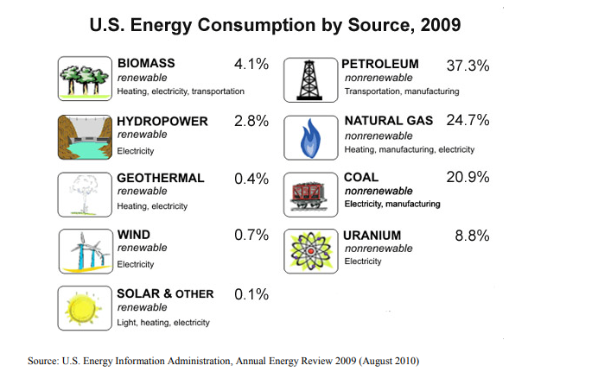

# Investigation - Bias

Now we’re going to learn how to conduct an unbiased literature search in order to understand the advantages and disadvantages of different energy sources:

1. Split into 2 groups:

2. Read the following paragraphs and detect bias in each one, record your notes in the respective shared google doc:

a. A new solar photovoltaic array was constructed in California yesterday. The panels were an expensive local solution to global warming, which itself has not been proven. It remains to be seen how much electricity is actually generated by the panels and whether the neighbors object to the “new look” of their community.

<https://docs.google.com/document/d/1eFzXm-zlCUO7acAWySLDfQ0LrfiLNNGN3rC-w2Gd_O8/edit?usp=sharing>

b. A new solar photovoltaic array was constructed in California yesterday. The panels were tastefully installed to match the surrounding environment and will reduce energy costs for participating customers. “This technology benefits everyone – the customers, the environment, the economy, and the community”, said Joe Schmidt, a local solar installer.

<https://docs.google.com/document/d/10Fy50HYF9HtVmuM8ef1o2sBKKO1IED7vJCFO2WDHE6w/edit?usp=sharing>

2. Responses:

* Paragraph a:
* Paragraph b:

# Investigation – Specific Energy Source

3. Split into groups of 3-4 to research a specific energy source via the internet.

4. Research should be recorded in the respective google doc and please cite unbiased websites/articles when possible.

5. Each group will present to the class about their specific energy source and the answers to the following questions:

Group 1: Coal

<https://docs.google.com/document/d/1Pr_ikr5nz5ehLEZhwof3yswZ6OYXkYdNF8sn_XOAu3E/edit?usp=sharing>

Group 2: Hydropower

<https://docs.google.com/document/d/1q7HorX3JOA_7hz_aVkisCGV5sclo9fsJ2zr8oVcU7HI/edit?usp=sharing>

Group 3: Wind

<https://docs.google.com/document/d/1oE6oyW1bpjA3zFz2M3j1fINEvFEoQbKyyu90WgTmprc/edit?usp=sharing>

Group 4: Solar

<https://docs.google.com/document/d/1_ZqgoKMRkEAiLZ6ny0e7xvL6Na7qNy8zbfsNNbBtZ48/edit?usp=sharing>

a. Energy source name.

b. Is it renewable or non-renewable?

c. If non-renewable, how many years of world/U.S. reserves are left?

d. Is it used for electricity generation, heating, and/or transportation fuel?

e. What percent of California’s electricity or heating does the source supply? What percent of the U.S.’s transportation fuel does the source supply?

f. How is the source converted into usable energy?

g. Can the energy source produce energy upon demand (instantly)?

h. Is the energy from the source commonly used where it is generated?

i. Use resource maps or other data to comment on the abundance of the source in California and in your region of California.

j. How does the cost of using the energy source compare to alternatives?

k. What are the environmental costs and benefits of the energy source, including impacts on wildlife habitat, ecosystems, and the atmosphere?

l. Do you believe the source is overutilized, underutilized, or utilized at the right level in California? Why?

# U.S. Energy Consumption

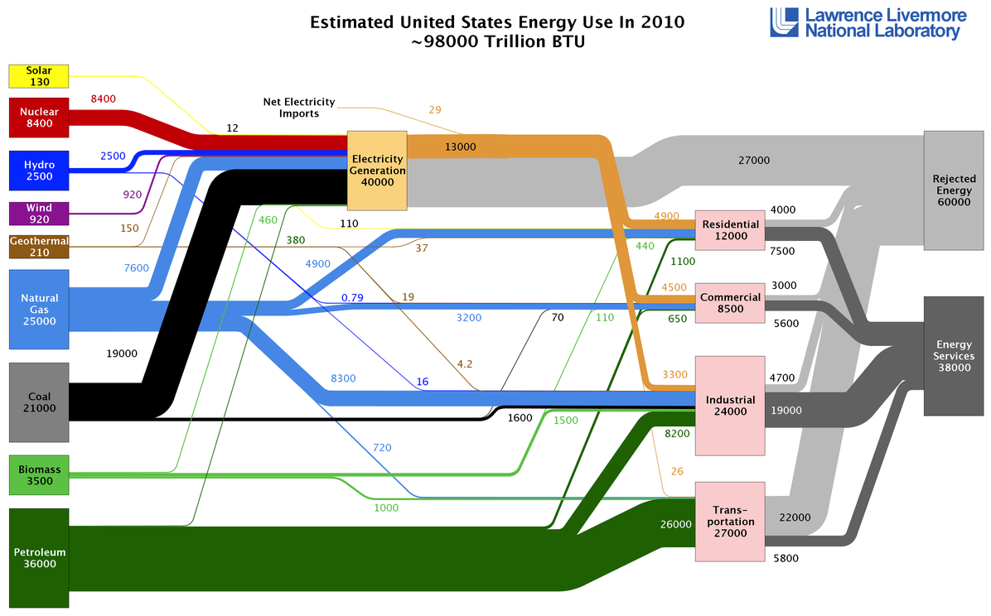

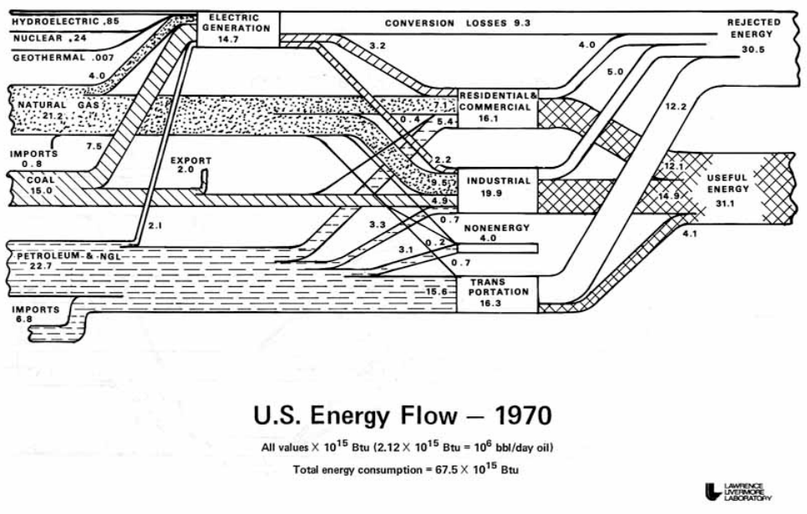

# Concluding Thoughts – Colorado Example

<https://www.renewableenergyworld.com/2010/03/26/colorado-boosts-its-rps-to-30-by-2020/>

1. Is a 30% Renewable Portfolio Standard too high, too low, or just right?

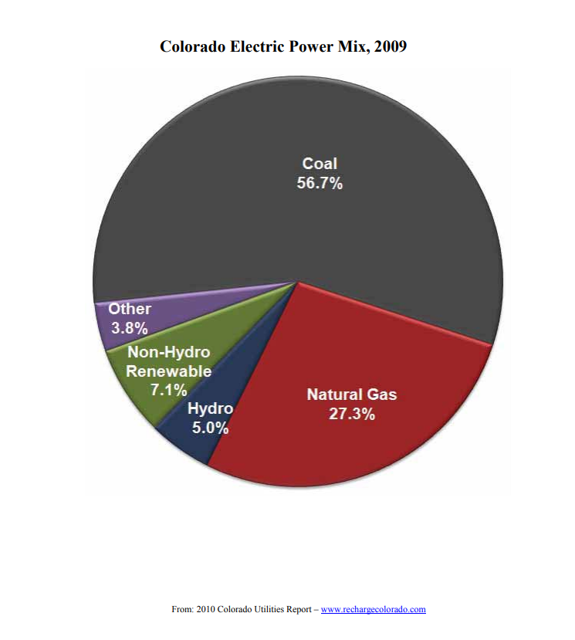2. Let’s discuss a vision for Colorado’s energy source mix by 2020 and 2050.

# Exit Survey

<https://forms.gle/bTMVGvZ52fj5nz8YA>